## Restoring a SQL Server Backup

### Objective
This section documents shows how to restore a SQL Server database using a backup file.

### Steps

1. Open SQL Server Management Studio (SSMS).
2. Connect to the SQL Server instance.
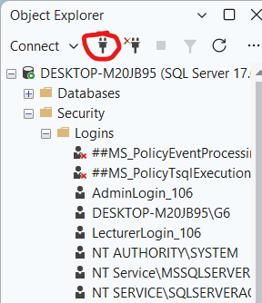

3. Right-click on Databases.
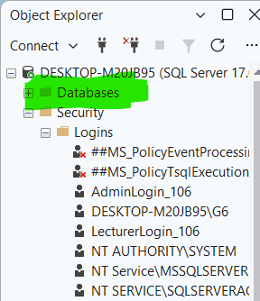

4. Select Restore Database from the pop-up menu.
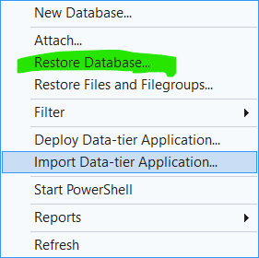

A window will appear
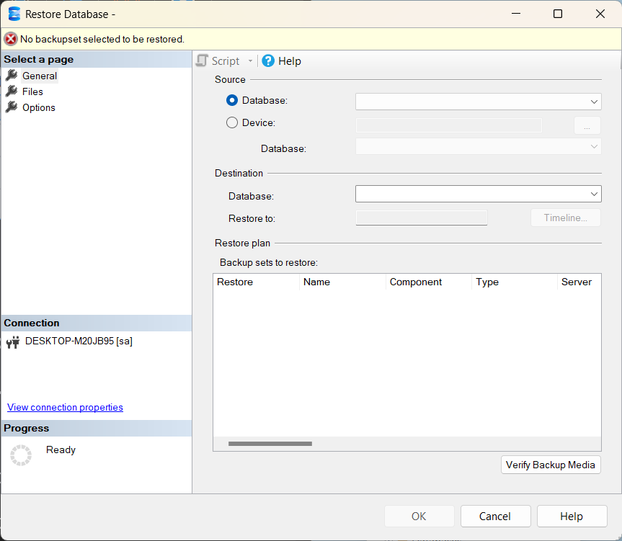

5. Select Device as the backup source.
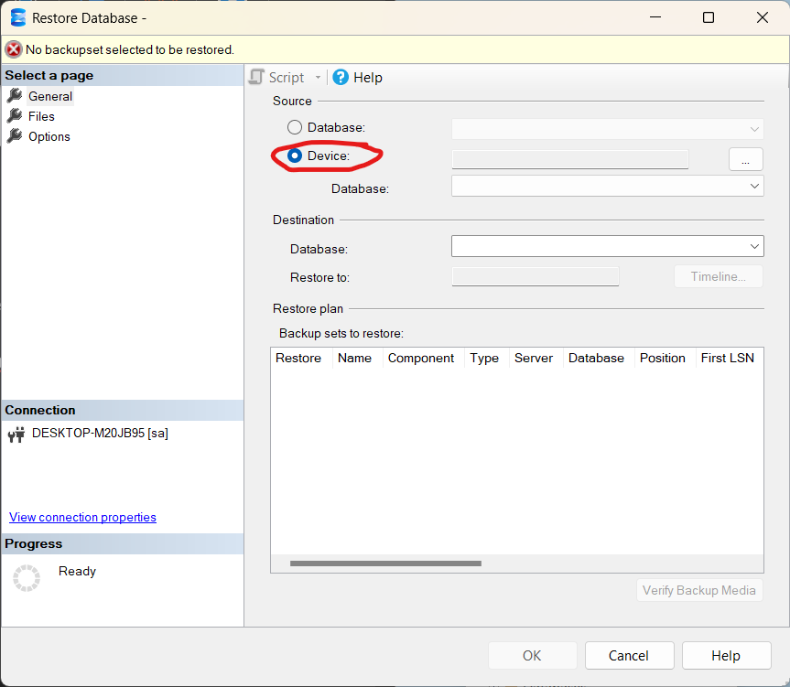

6. Click the three dots (...) to select the backup file.
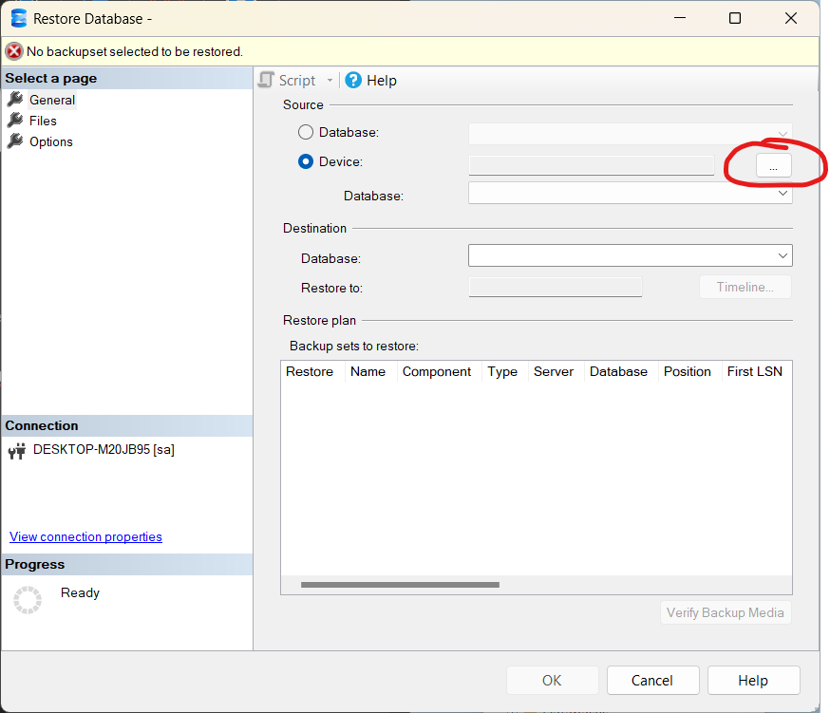
A window will appear.
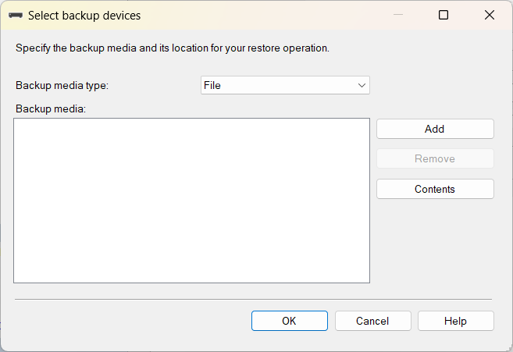

7. Ensure that the backup media type is set to File and click on add.
8.Browse to the folder containing your .bak file, select it and click OK. Click OK again to return to the main window.
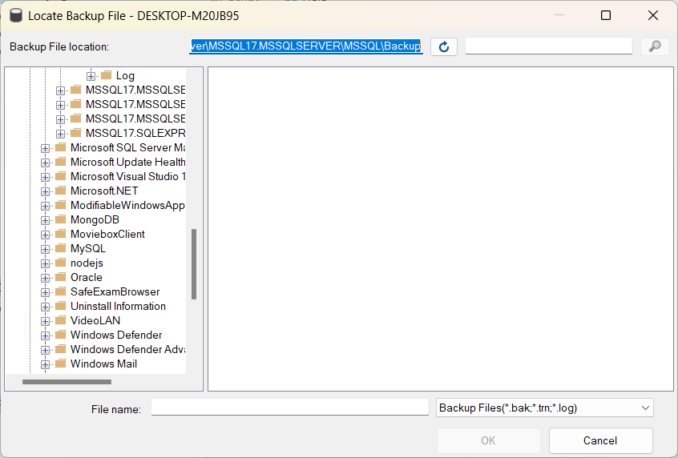

9. Select the database to restore.
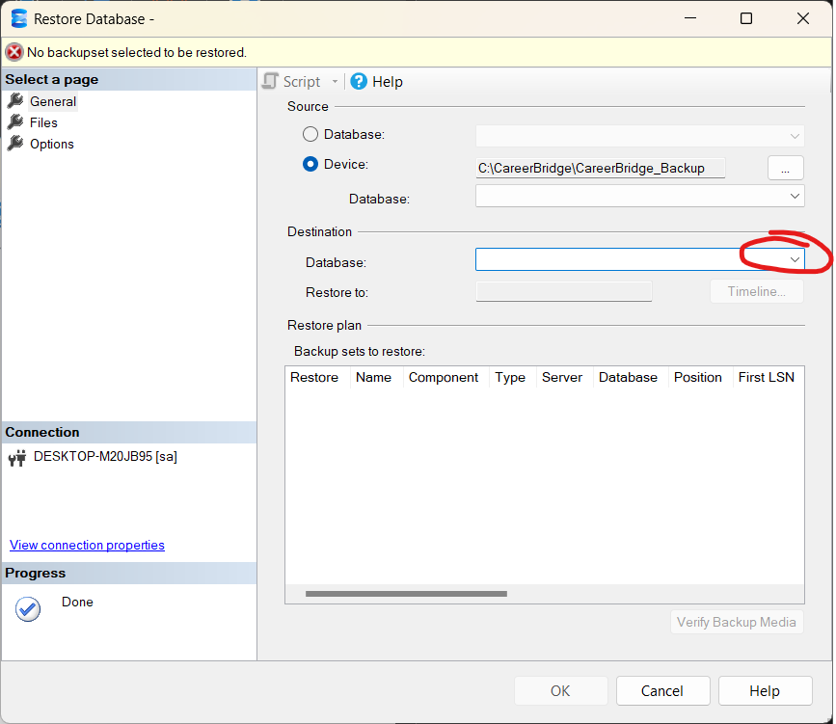

9. Review the restore settings.
10. Click OK to restore the database.

